Liverpool Street School Active Challenge

Daily Challenge try to do 10 of those activities a day and have all of them done by the end of the week
1  2Km Walk or Run   | 2  25 sit up | 3  Joggle for 5 minutes  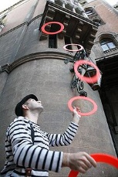 | 4  Balance for 2 minutes on one foot then change foot  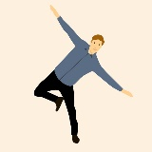
5  25 Jumping Jacks  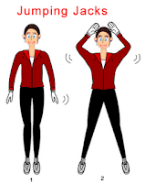 | 6  Toss a objet for 10 minutes   | 7  25 minutes Biking/  Roller Blading /Skateboarding   | 8  Dribble with your hands or feet’s for 10 minutes  
9  25 Push-up  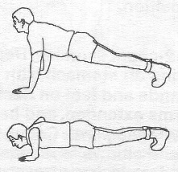 | 10  Hop for 2 minutes | 11  60 second Wall Chair  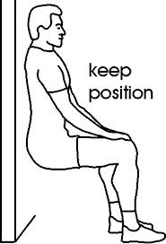 | 12  25 Burpees  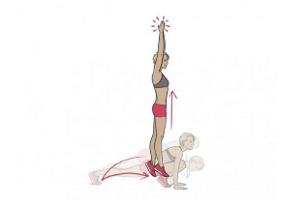
13  50 Squats in a day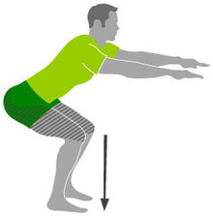 | 14  Crabbe walk for 2 minutes   | 15  60 second Planks  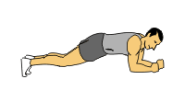 | 16  Play catch for 10 minutes  

